**IT24103033**

**Dinuwara K.D.S**

**Lab 05**

**Exercise**

1.



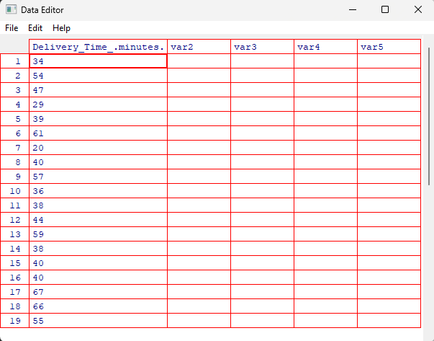

2.

3.



4.

